W-16

**YEAR 12 PHYSICS**

**ASSIGNMENT 5 - INDUCED EMF**

**Name:** **Mark:** 

1. A 12.5 cm long piece of copper wire is moved at a constant velocity of 6.56 ms-1 through a magnetic field of 0.150 T. Calculate the potential difference between the ends of the wire and indicate on the diagram which end of the wire is positive. (3 marks)

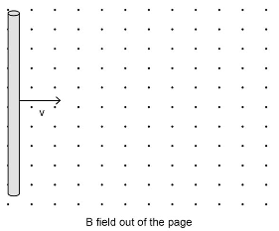

2. Explain, using an appropriate formula, why high-voltage power lines are used when transporting electrical power over large distances. (3 marks)

3. The diagram below shows a cross-section of a simple dynamic microphone. Describe how a musical note played near the diaphragm of the microphone can be detected by an amplifier. Your description should include an explanation of how the sound is converted to an electrical signal. (4 marks)

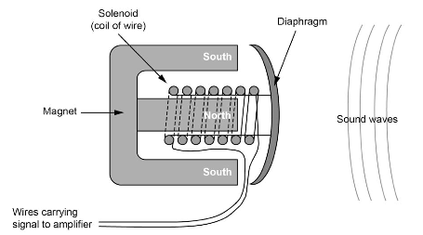

4. As a rectangular coil loop (UVXY) is moved from left to right, it enters a uniform magnetic field, B, as shown in the diagram below. The plane of the loop is perpendicular to the magnetic field lines. According to Faraday’s law, an emf must be induced in the loop. Assume that the emf induced in the U-V-X-Y direction is negative, while in the Y-X-V-U direction the emf is positive.

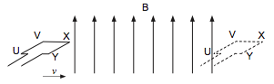

(a) A meter is connected to the loop to measure the emf generated in the circuit during one movement through the field. Fill in the following details of the meter. (2 marks)

  Type of meter:

Unit of measurement:

(b) During a second movement through the field, a light globe is attached between U and Y, making a circuit. Explain why the loop requires a force when entering and leaving the magnetic field. (4 marks)

(c) Given that the velocity of the loop is constant, complete the graph below for the emf induced in the loop over the time that it moves into and out of the field. (4 marks)

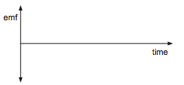

(d) Another method of generating an emf is to move the magnet in a circular motion as shown in the diagram below.

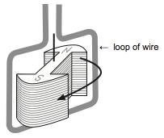

(i) Complete the graph below for the emf induced in the loop of wire over one complete rotation of the magnet. (3 marks)

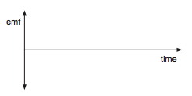

(ii) The loop of wire above is a square 5.00 cm × 5.00 cm. If the magnet rotates once every 1.00 s and has a magnetic field strength of 0.789 T, calculate the magnitude of the maximum emf generated. Assume that the field is completely reversed in the loop during the magnet’s rotation. Show all workings. (4 marks)

5. A mobile phone, of resistance 4.00 Ω was connected to a charger (actually a small step- down transformer). The details of the charger are shown below.

Assume the charger to be 100% efficient.

**PRIMARY COIL SECONDARY COIL** Input voltage: 240 V AC 50 Hz Output voltage 5.00 V AC 50 Hz Turns: 432 Turns: 9 Power: 6.25 W

The 5.00 V AC output of the charger was rectified to 5.00 V DC before charging the battery in the phone.

(a)   State the power output of the secondary coil of the charger. W (1 mark)

(b)   Calculate the current flowing through the secondary coil while the battery was charging. Show **all** workings. (2 marks)

(c) When the mobile phone is charging, 5.00 V DC is used to charge the battery.

(i)   State the number of joules carried by each coulomb of charge. (1 mark)

(ii)   Calculate the amount of energy, in joules, carried by each electron as it charges the battery. Show **all** workings. (3 marks)  

(d) The graph below shows the change in flux experienced by the secondary coil over one complete cycle.

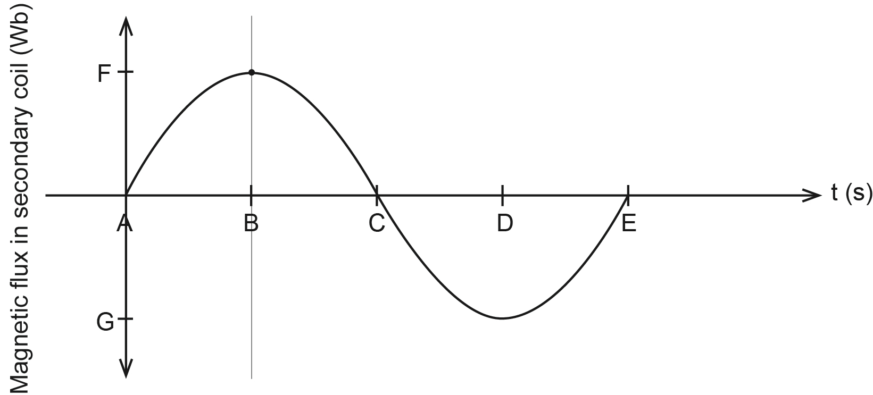

By calculating any required values, and showing **all** workings, determine the magnitudes of the

(i)   time interval AE: s.  (1 mark)

(ii)   time interval AB: s.  (1 mark)

(iii)   flux value F at time B: Wb.  (3 marks)

6. A permanent magnet slides down a plastic track and passes through two solenoid coils. The coils are connected in series and their windings are in the same direction. A centre-zero galvanometer (a very sensitive ammeter) is also connected in series with the coils. Assume that the contact between the magnet and plastic track is frictionless.

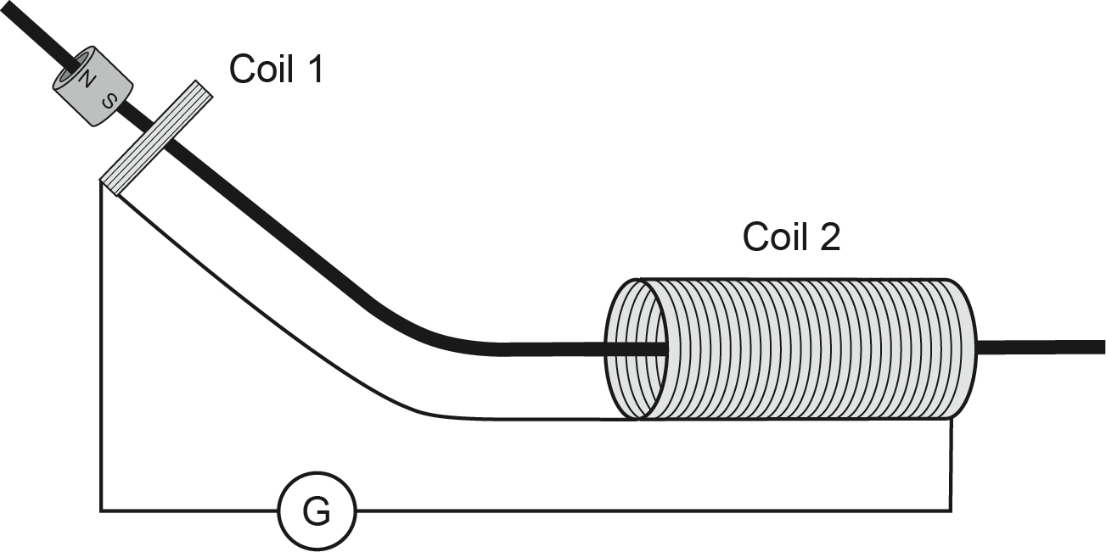

(a) Explain why a current is induced in a coil when the magnet enters and leaves it. (4 marks)

(b) State the expected reading on the galvanometer G as the magnet travels inside Coil 2. Justify your answer. (2 marks)

Reading:

Justification:

(c) Sketch the graphs of current versus time and velocity of the magnet versus time on the axes provided below. (8 marks)

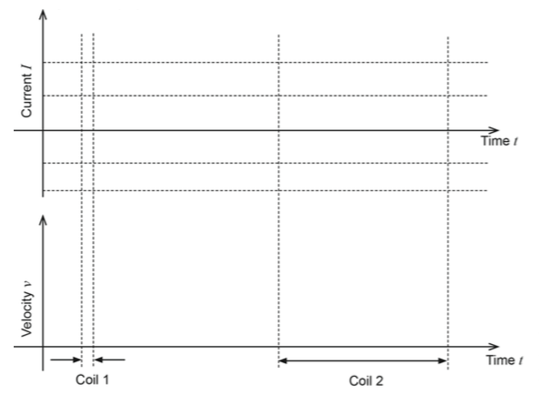

7. Inductive charging is becoming more popular for mobile devices such as phones. A simplified diagram of the charging system is shown below.

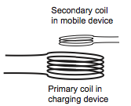

(a) Assume that one such charging system runs directly from the mains power (240 V AC) to charge a device that requires an input of 4.00 V. Describe the transformer and the relationship between the two coils. (3 marks)

(b) Use appropriate formulae or relationships to explain how this inductive charging system works. (3 marks)

8. Below is a photograph of a brick saw on a stand. The saw is powered by a 2.20 kW single- phase AC electric motor that draws current from the 240 V and 50.0 Hz mains supply. There is a very tight belt around the shaft of the blade and the shaft of the electric motor and this is how the spinning motor makes the blade spin. Bricks are cut by placing them on the platform and pushing them through the spinning blade.

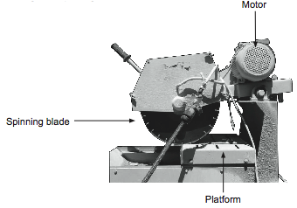

(a)   Calculate the current used by the saw when it is operating normally. (2 marks)

(b)   Calculate the size of the EMF generated by the coil if the supply is exactly 240 V and the losses due to inefficiency is 28.0 V. (2 marks)

(c)   When the motor is switched on, it speeds up until it reaches a maximum. Explain how the EMF generated in the coil restricts the speed of the motor. (4 marks)

(d) While the saw is operating, it suddenly stops spinning because it is stuck in a brick. The current through the saw will: (3 marks)

(i) increase.

(ii) decrease.

(iii) remain the same.

Circle your answer and explain your reasoning.

(e) On the axes below sketch the current in the saw when the saw is operating normally and when it is stuck in a brick. (3 marks)

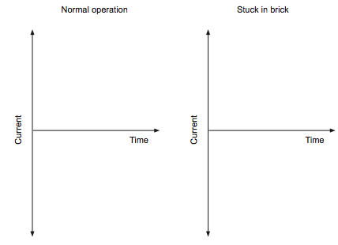

9. In the diagram below a copper rod is free to slide down two parallel electrical contact rails, which are mounted, on an inclined plane. The inclined plane is a strong magnet. The angle, θ, between the inclined plane and the horizontal can be changed. The electrical contact rails are connected to a galvanometer.

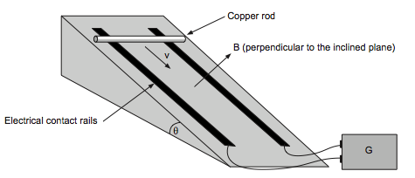

As the rod slides, it first accelerates but eventually reaches a constant, terminal speed.

(a) Explain why a current is detected by the galvanometer when the copper rod moves.  (2 marks)

(b) Explain why there is a force opposing the rod’s motion down the rails. (2 marks)

A group of students investigate the relationship between the terminal speed of the rod and the angle of inclination. They measure the terminal speed of the rod using data-logging equipment angle of inclination. They measure the terminal speed of the rod using data logging equipment and the angle of inclination with a protractor. They plot their data on a graph. This graph is reproduced below. 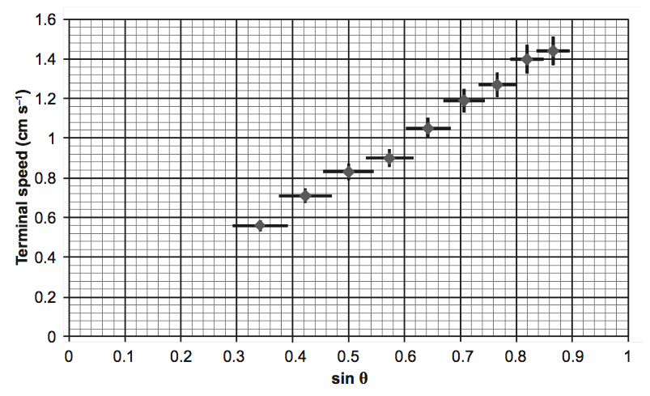

(c) Express the value of terminal speed, when sine θ = 0.5 in the form y±∆y where y is the value of terminal speed and ∆y is the uncertainty in the measurement. (2 marks)

(d) Describe the trend in uncertainty for the terminal speed and the sine of the angle θ. (4 marks)

(e) When drawing the line of best fit the students chose not to include the two largest terminal speed measurements from their data because they thought these two measurements were less reliable. Refer to the graph to explain why they thought this. (3 marks)

(f) Draw a line of best fit onto the graph and determine the gradient of the line. (3 marks)

(g) The rod’s terminal speed can be calculated from the equation  where *m* = 44.0 g, *R* = 1.4 × 10-4 Ω and *l* = 20.0 cm. Use your value of the gradient to calculate a value of the magnetic field strength *B*. If you were unable to determine a value for the gradient, you should use 1.57 cms−1. (2 marks)

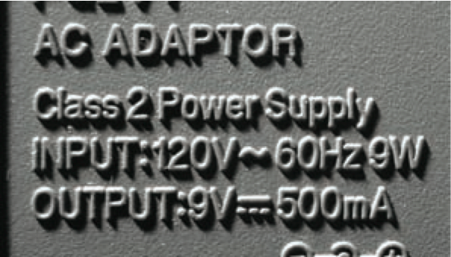10. This photograph shows the information on a compliance plate on the outside of a small transformer used in a house in another country.

(a) Determine the ratio of windings of primary : secondary coils in the transformer. (2 marks)

(b) Using the information on the compliance plate, calculate the power output of the transformer and use this information to determine the percentage efficiency of the transformer. (3 marks)

(c) Explain why the input voltage must consist of an alternating current rather than direct current. (2 marks)

(d)   The following photograph shows the coils and core inside the transformer case.

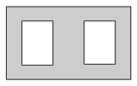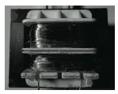 For small commercial transformers, the coils are placed around the centre pillar of the core, which is shaped like this:

Describe the purpose and properties of the core. (2 marks)

  (e)   The photograph below shows the laminae (a number of thin iron sheets separated by non-electrically conductive material, such as plastic) that make up the core. These laminae are used to reduce ‘eddy currents’ or ‘back emf’ and make transformers more efficient.  Use the following diagrams representing the centre pillar of the transformer and any relevant formula to explain why a transformer with a laminated core is more efficient than a transformer with a solid core. (4 marks)

